**Graduation Project**

**Academic Year 2023-2024**

**Faculty and Students Scheduling Information System (FSSIS)**

**Assiut University**

**Faculty of Computers & Information**

**Department of …**

Project Team

Amr Abdo Saber Shaaban

Omar Nasr Mohamed Salama

Ali Ossama Ali Mohamed

Abd-El Monem Khamis Ishmail Hassan

Fatma Mahmoud Wadia Sheref

Fatma Mahmoud Abd-El-Tawab Gad El-Rab

Ghada Helal Zakaria El-Said Salama

Supervisor

Dr. Naglaa

Eng. Omnia

**2023/2024**

Table of Contents

1.Project Abstract 4

2.Project Objectives 5

3.Project Plan and Management 6

4.Introduction 8

4.1 Purpose 8

4.2 Document Conventions 8

4.3 Intended Audience and Reading Suggestion 8

4.4 Product Scope 11

4.5 Problem Introduction 12

4.6 Goals 14

4.7 Ovwerview 17

5. Overall Description 21

5.1 Product Perspective 21

5.2 Modules 24

5.3 Product Functions 31

5.4 User Classes and Characteristics 32

5.5 Operating Environment 35

5.6 Design and Implementation Constraints 41

5.7 User Documentation 44

5.8 Project Documentation 46

5.9 Assumptions and Dependencies 47

6. External Interface Requirements 49

6.1 User Interfaces 49

6.2 Hardware Interfaces 68

6.3 Software Interfaces 68

6.4 Communications Interfaces 69

7. System Features 69

7.1 Function Requirement 69

7.2 Non-Function Requirement 74

7.3 DataBase Table & Relationship 76

7.4 ERD Diagram 84

7.5 Use Case Diagram 85

7.6 Use Case Scenarios 87

7.7 Activity Diagram 98

8. Other Nonfunctional Requirements 107

8.1 Performance Requirements 107

8.2 Safety Requirements 107

8.3 Security Requirements 108

8.4 Software Quality Attributes 109

8.5 Business Rules 111

9. Other Requirements 111

10. Revition history 113

# 1. Project Abstract

The Faculty and Students Scheduling and Information System (FSSIS) benefits both students, professors, and teaching assistants by providing them with detailed schedules and information related to the college, including lectures, sessions, and their respective locations and times. It helps students to be aware of all the professors available in their academic year, as well as the academic subjects and the individuals responsible for teaching them, whether professors or teaching assistants.

Furthermore, the project assists professors in knowing the timing and location of lectures, as well as their office hours. It also aids IT technicians in understanding the status of all devices in the college, enabling them to perform necessary repairs. Additionally, it supports student affairs personnel in obtaining details about the facilities, such as available equipment and chairs suitable for use during exams. This information proves valuable for organizing students into examination committees.

By providing such comprehensive data, the project streamlines the work of professors, students, student affairs staff, and IT technicians through the scheduling system.

# 2. Project Objectives

The Faculty and Students Scheduling and Information System (FSSIS) aims to facilitate the process of knowing the schedules and locations of lectures and sessions for both students, professors, and teaching assistants without the need to consult multiple schedules. This provides them with schedule stability and prevents conflicts in timings. In the event of any schedule changes, everyone can be informed of such changes and can act accordingly without having to refer to student affairs.

Moreover, the project enables individuals to know the detailed locations of professors' and teaching assistants' offices, along with their office hours. It also allows administrators to have a comprehensive overview of all schedules for students, professors, and teaching assistants.

It also aims to improve the quality of facilities and equipment by allowing IT technicians to identify devices that have malfunctions and require maintenance. This includes computers, air conditioning units, chairs, and projectors found in laboratories and lecture halls.

# 4.Project Plan and Management

|  |  |  |
| --- | --- | --- |
| Project Name | Faculty and Students Scheduling Information System (FSSIS) | |
| Project Leader | | Omar Nasr |
| Project Deliverable | | Website that can manage Faculty |
| Start Date | | 15 / 12 / 2023 |
| End Date | | 10 / 2 / 2024 |
| Overall Progress | | |

|  |  |  |  |  |
| --- | --- | --- | --- | --- |
|  |  | All Team | Analysis of project | 1 |
|  |  | All Team | Collection of requirements | 2 |
|  |  | Amr Abdo | Learning UI/UX | 3 |
| Ghada Helal | Fatma Mahmoud | Ali Osama | Learning Front-End | 4 |
| AbdelmonemKhamis | Fatma Mahmoud | Omar Nasr | Learning Back end | 5 |
|  |  | All Team | Learning libraries, using them in our project | 6 |
|  |  | All Team | Project Document and Presentation | 7 |
|  |  | All Team | Project Discussion | 8 |
|  |  | Amr Abdo | Design UI/UX for the project | 9 |
| Ghada Helal | Fatma Mahmoud | Ali Osama | Start Implementation of Front-End | 10 |
|  |  | All Team | Test Project | 11 |
| Abdelmonem Khamis | Fatma Mahmoud | Omar Nasr | Start Implementation of Back end | 12 |
|  |  | All Team | Test Project | 13 |
|  |  | All Team | Project Discussion | 14 |

# 4.Introduction

## 4.1 Purpose

The purpose of the project is to provide comprehensive information about the schedules of students, professors, and teaching assistants. It also includes details about the occupancy times of laboratories and lecture halls. This enables the identification of available laboratories and lecture halls, if the administration may need them for seminars, meetings, or other events. Additionally, the project encompasses information about all the devices present in the college, whether in laboratories or lecture halls.

## 4.2 Document Conventions

Main title: (font: Times New Roman (Headings CS), size: 18px, Bold, color: Purple)

Subtitle: (font: (font: Times New Roman (Headings CS), size:18pt, Bold, color: Purple)

Paragraph: (font: (font: Times New Roman (Headings CS), size:16pt, color: Black)

## 4.3 Intended Audience and Reading Suggestion

Intended Audience:

1. Students:

-The scheduling system is designed to benefit students from all four academic years and both general and specialized departments. It provides them with easy access to their class schedules, locations, and information about professors.

2. Professors and Teaching Assistants:

- The project is intended for professors and teaching assistants who can utilize the system to manage and access their teaching schedules, office hours, and office locations.

3. Student Affairs Personnel:

- Individuals involved in student affairs can use the system to access information about facilities, including laboratories and lecture halls, helping them organize events and allocate spaces effectively.

4. IT Technicians:

- The project caters to IT technicians who can benefit from information about the status of devices in laboratories and lecture halls, helping them identify and address technical issues promptly.

5. College Administration:

- The administrative staff of the college can use the system to gain an overview of schedules, facilities, and device status, facilitating better coordination and decision-making.

Reading Suggestion:

For a comprehensive understanding of the project, the intended audience is recommended to review the following documents:

1. User Manuals:

- Detailed manuals providing step-by-step instructions on how to navigate and utilize the scheduling system for students, professors, teaching assistants, student affairs personnel, and IT technicians.

2. Administrator's Guide:

- A guide specifically for college administrators, detailing how to access and interpret overall scheduling information, manage events, and make informed decisions based on the data provided by the system.

3. Technical Documentation:

- In-depth technical documentation for IT technicians, outlining the system architecture, device monitoring processes, and procedures for addressing technical issues.

4. Training Materials:

- Training materials, including videos or presentations, to facilitate a smooth onboarding process for users, ensuring they are familiar with the functionalities of the system.

5. Feedback Mechanism:

- Information on how users can provide feedback on the system's usability and any suggestions for improvements, fostering continuous enhancement of the platform based on user experiences.

## 4.4 Product Scope

The product scope of this project includes the development of a comprehensive information system or platform that provides scheduling details for students, professors, and teaching assistants across all four academic years. It covers both general and specialized departments within the college. The system should also include information about the occupancy status of laboratories and lecture halls, enabling users to identify available spaces for seminars, meetings, or other events.

Additionally, the project's product scope involves incorporating details about the various devices present in the college, including those in laboratories and lecture halls. The goal is to facilitate the identification of faulty devices that require maintenance by IT technicians.

In summary, the product scope encompasses a centralized information system that streamlines scheduling, occupancy information, and device status for the benefit of students, faculty, administrative staff, and IT technicians within the college.

## 4.5 Problem Introduction

The problem introduction for this project involves several challenges and inefficiencies within the current system or lack thereof. Here's a breakdown of potential problems that the project aims to address:

1. Disparate Scheduling Systems:

- The absence of a centralized scheduling system results in students, professors, and teaching assistants having to refer to multiple schedules, leading to confusion and potential scheduling conflicts.

2. Limited Facility Information:

- Lack of readily available information about the occupancy status of laboratories and lecture halls makes it difficult for student affairs personnel to organize events efficiently or for administrators to allocate spaces appropriately.

3. Ineffective Device Monitoring:

- Without a comprehensive system, IT technicians may struggle to monitor the status of devices in real-time, resulting in delayed identification and resolution of technical issues in laboratories and lecture halls.

4. Manual Communication Processes:

- The reliance on manual communication methods for schedule changes, room availability, and device issues can lead to delays, miscommunication, and a lack of real-time updates for all stakeholders.

5. Limited Accessibility to Information:

- Students, professors, and other staff members may face challenges in accessing crucial information about schedules, facilities, and device status, hindering their ability to plan and perform their duties effectively.

6. Event Coordination Challenges:

- The absence of a unified system makes it challenging for student affairs personnel to coordinate seminars, meetings, or other events due to a lack of readily available information about available spaces and scheduling conflicts.

7. Insufficient Data for Decision-Making:

- College administrators may lack comprehensive data on schedules, facility usage, and device status, hindering their ability to make informed decisions and optimize resource allocation.

Addressing these problems through the implementation of a centralized scheduling and information system is the primary objective of the project, aiming to streamline processes, enhance communication, and improve overall efficiency within the college environment.

## 4.6 Goals

The goals of this project are centered around addressing the identified problems and improving the overall efficiency and effectiveness of scheduling, information dissemination, and facility management within the college. Here are the key goals:

1. Centralized Scheduling System:

- Implement a centralized scheduling system accessible to students, professors, and teaching assistants, providing a single source of accurate and up-to-date information on class schedules, locations, and changes.

2. Facility Occupancy Management:

- Develop a system that allows student affairs personnel to efficiently manage the occupancy status of laboratories and lecture halls, enabling better organization of events and optimal use of available spaces.

3. Real-time Device Monitoring:

- Establish a system for IT technicians to monitor the status of devices in laboratories and lecture halls in real-time, facilitating prompt identification and resolution of technical issues.

4. Automated Communication:

- Implement automated communication channels to notify all stakeholders, including students, professors, and staff, about schedule changes, room availability, and any other relevant information, reducing manual communication challenges.

5. Enhanced Accessibility:

- Ensure that the scheduling system is user-friendly and accessible to all stakeholders, promoting ease of use and efficient retrieval of information about schedules, facilities, and device status.

6. Comprehensive Information System:

- Create a comprehensive information system that provides administrators with detailed insights into schedules, facility usage, and device status, empowering data-driven decision-making, and resource optimization.

7. Event Coordination Support:

- Support student affairs personnel and Collage Admin in coordinating seminars, meetings, exams, and other events by providing instant information on available spaces and avoiding scheduling conflicts.

8. User Training and Support:

- Develop training materials and support mechanisms to ensure that all users, including students, professors, and administrative staff, are proficient in using the system and can maximize its functionalities.

9. Feedback Mechanism:

- Establish a feedback mechanism to gather input from users, allowing continuous improvement of the system based on user experiences and evolving needs.

By achieving these goals, the project aims to create a more streamlined, transparent, and efficient environment within the college, benefiting students, faculty, administrators, and technical staff alike.

## 4.7 Overview

Objective:

The primary objective of this project is to develop and implement a centralized information system for a college environment. The system aims to streamline scheduling, enhance communication, and improve facility management, benefiting students, professors, administrative staff, and IT technicians.

Key Features:

1. Centralized Scheduling:

- Single platform for students, professors, and teaching assistants to access and manage class schedules, locations, and changes.

2. Facility Occupancy Management:

- Real-time tracking of laboratory and lecture hall occupancy, aiding student affairs in event coordination and space optimization.

3. Device Monitoring and Maintenance:

- System for IT technicians to monitor the status of devices in laboratories and lecture halls, facilitating timely identification and resolution of technical issues.

4. Automated Communication Channels:

- Implementation of automated communication channels to notify stakeholders about schedule changes, room availability, and other relevant information.

5. Accessibility:

- User-friendly interface ensuring easy access to information for students, professors, and staff regarding schedules, facilities, and device status.

6. Comprehensive Information System:

- Detailed insights for administrators into schedules, facility usage, and device status, enabling data-driven decision-making and resource optimization.

7. Event Coordination Support:

- Instant information on available spaces for student affairs personnel to coordinate seminars, meetings, and other events efficiently.

8. User Training and Support:

- Development of training materials and support mechanisms to ensure users are proficient in utilizing the system's functionalities.

9. Feedback Mechanism:

- Establishment of a feedback mechanism for continuous improvement based on user experiences and evolving needs.

Target Audience:

- Students from all four academic years and both general and specialized departments.

- Professors and teaching assistants.

- Student affairs personnel.

- IT technicians.

- College administrators.

Expected Outcomes:

- Streamlined scheduling processes.

- Improved communication and coordination.

- Efficient facility management.

- Timely resolution of technical issues.

- Enhanced user satisfaction and productivity.

Project Phases:

1. Requirements Gathering and Analysis:

- Identify and document the specific needs and challenges of students, faculty, and staff.

2. System Design and Development:

- Develop a comprehensive system architecture and implement the necessary features.

3. Testing and Quality Assurance:

- Thoroughly test the system to ensure functionality, security, and user-friendliness.

4. Deployment:

- Roll out the system to the college community, providing necessary training and support.

5. Feedback and Iterative Improvements:

- Establish mechanisms for gathering user feedback and implement iterative improvements to enhance the system continuously.

Project Timeline:

- The project is expected to be completed within a specified timeframe, ensuring a prompt and effective solution to the identified challenges.

By achieving these objectives, the project aims to create a more efficient and collaborative environment within the college, ultimately enhancing the overall academic experience for students and optimizing administrative processes.

# 5. Overall Description

## 5.1 Product Perspective

The product perspective provides an understanding of how the proposed system fits into the broader context of the organization or environment. It outlines the relationships and interactions the system has with other entities, systems, or processes. In the context of the centralized college information system project, the product perspective involves several key aspects:

1. System Interfaces:

- Describe the external systems, software applications, or devices with which the centralized information system interacts. This may include integration points with existing databases, external communication channels, or third-party tools.

2. User Interfaces:

- Detail the interfaces that different user roles (students, professors, teaching assistants, administrators, etc.) will interact with. This includes the design and functionality of the user interfaces tailored to each user group.

3. Hardware Interfaces:

- Specify any hardware requirements or interactions necessary for the system's functionality. This could include compatibility with specific devices or equipment used in laboratories or lecture halls.

4. Software Interfaces:

- Identify the software components and applications that the centralized information system interfaces with. This may involve integration with existing software used by the college, such as academic management systems or communication tools.

5. Communication Protocols:

- Outline the protocols and standards used for communication within the system and with external entities. This could include data exchange formats, networking protocols, and security measures.

6. Dependencies:

- Identify any dependencies the system has on external factors, such as external databases, network infrastructure, or third-party services. Understanding these dependencies is crucial for ensuring the system's reliability and performance.

7. Regulatory Compliance:

- Consider any legal or regulatory requirements that the system must adhere to. This includes data protection regulations, privacy policies, and any industry-specific compliance standards relevant to the college environment.

8. Lifecycle Integration:

- Describe how the system will be integrated into the existing organizational workflow and how it aligns with the overall lifecycle of other systems or processes within the college.

9. Scalability and Extensibility:

- Address the system's scalability to accommodate potential growth in user base or additional functionalities in the future. Consider how easily the system can be extended or modified to meet evolving requirements.

Understanding the product perspective is essential for ensuring that the proposed centralized college information system seamlessly integrates with existing infrastructure, meets user needs, and aligns with organizational goals and standards. This perspective helps in identifying potential challenges, dependencies, and opportunities for collaboration with other systems or processes within the college environment.

## 5.2 Modules

In the context of software development, modules refer to self-contained, functional components or units of a larger system. Each module performs a specific set of tasks and has well-defined interfaces for interacting with other modules. For the centralized college information system project, various modules can be identified based on the functionalities and features required. Here are potential modules for such a system:

5.2.1. Student Module:

- Allows students to view and manage their class schedules, access information about professors, view grades, and receive notifications about schedule changes.

Here's an outline of the functionalities within the Student Module:

5.2.1.1. Class Schedule Access:

- Provides students with a user-friendly interface to view and access their class schedules, including details on lecture timings, locations, and any schedule changes.

5.2.1.2. Professor Information:

- Access to information about professors, including their names, contact details, and office hours. Facilitates communication with professors for inquiries and consultations.

5.2.1.3. Grades and Academic Performance:

- View grades for completed assignments, quizzes, and exams. Access to an overview of academic performance and cumulative GPA.

5.2.1.4. Office Hours Booking:

- Capability to view and book appointments during professors' office hours for consultations, clarifications, or discussions.

Separating these functionalities into a dedicated Student Module provides a cohesive and user-friendly platform for students to manage their academic journey, communicate effectively, and access important information related to their studies. Each feature is designed to enhance the student experience and streamline their interactions with the academic environment.

5.2.2. Professor:

- Enables professors to manage their teaching schedules, office hours, and access information about students.

Here's an outline of the distinct functionalities within the Professor modules:

5.2.2.1. Class Schedule Management:

- Ability to view, manage, and update class schedules for the courses they are teaching, including details on lecture timings, locations, and any changes.

5.2.2.2. Office Hours Management:

- Allows professors to set and manage their office hours, providing students with dedicated time for consultations and discussions.

5.2.2.3. Student Information:

- Access to information about enrolled students, including names, contact details, and academic performance. Facilitates communication with students.

5.2.2.4. Grade Submission:

- Capability to submit and manage grades for assignments, exams, and other assessments. Integrates with the grading system of the academic department.

5.2.3. Teaching Assistant (TA) Module:

- Enables teaching assistants to manage their teaching schedules, office hours, and access information about students.

Here's an outline of the distinct functionalities within the Teaching Assistant modules:

5.2.3.1. Assistance in Class Management:

- Collaborates with professors in managing class schedules, assignments, and assessments. Access to relevant course materials and syllabi.

5.2.3.2. Support in Office Hours:

- Assists in managing and conducting office hours alongside professors, providing additional availability for student consultations.

5.2.3.3. Student Assistance:

- Access to student information to assist professors in responding to queries, grading assignments, and providing academic support.

5.2.3.4. Communication Support:

- Utilizes communication tools to facilitate interactions between professors and students. May assist in moderating discussion forums or providing additional resources.

5.2.3.5. Assignment and Grading Support:

- Assists in the preparation, distribution, and grading of assignments, quizzes, and exams. Collaborates with professors to maintain consistency in grading.

Separating these roles into distinct modules allows for a more specialized and efficient workflow tailored to the unique responsibilities and needs of professors and teaching assistants within the academic environment. Each module can be designed to optimize the user experience and streamline specific tasks associated with their roles.

5.2.4. IT Technician Module:

- Monitors the status of devices in laboratories and lecture halls, tracks reported technical issues, and facilitates the resolution of hardware or software problems.

Here's an outline of the functionalities within the IT Technician Module:

5.2.4.1. Device Monitoring Dashboard:

- Centralized dashboard for IT technicians to monitor the status of devices in laboratories and lecture halls. Provides real-time insights into the health and performance of hardware and software.

5.2.4.2. Device Inventory Management:

- Maintains a comprehensive inventory of devices in laboratories and lecture halls. Includes details such as device specifications, purchase dates, and maintenance history.

5.2.4.3. Scheduled Maintenance Planning:

- Enables IT technicians to plan and schedule routine maintenance tasks for devices, ensuring optimal performance and longevity.

5.2.4.4. Fault Diagnosis Tools:

- Provides diagnostic tools and utilities to aid IT technicians in identifying and troubleshooting hardware and software faults effectively.

5.2.4.5. Repair and Maintenance Workflow:

- Streamlines the workflow for repairing and maintaining devices. Allows technicians to document repairs, replacement of components, and update device statuses.

5.2.4.6. Documentation and Manuals:

- Access to comprehensive documentation and manuals for devices in use. Helps IT technicians in troubleshooting, maintenance, and repair procedures.

5.2.4.7. Device Utilization Reports:

- Generates reports on device utilization, helping IT technicians identify trends, plan for upgrades, and optimize resource allocation.

Separating these functionalities into a dedicated IT Technician Module provides IT staff with the tools and resources needed to effectively manage and maintain the technological infrastructure of the college. This module is designed to streamline the workflow of IT technicians, enhance collaboration, and ensure the reliability and performance of devices across laboratories and lecture halls.

5.2.5. Administrator Module:

- Provides administrators with a comprehensive overview of schedules, facility usage, and device status. Allows for system configuration, user management, and access to analytical reports.

These modules work together to create a cohesive and functional centralized college information system. Each module focuses on specific aspects of the system's functionality, promoting modularity, maintainability, and ease of future enhancements. The precise modules may vary based on the specific requirements and design decisions of the project.

## 5.3 Product Functions

1-LogIn: using National-number and password.

2-About us: view information about us.

3-Contact us: take data like (Full name, E-mail, Phone-number, comment).

4-New Student Enrollment Application: get some information that is needed.

5-Material: view all semesters for all levels and click on any of them to access google drive for material.

6-Courses: view all levels and click on any of them to know all courses for the current level.

7-Student/professor/teaching assistant table: view all schedules for the current module.

8-Professors: view all the current professors and their details for the current year.

9-Teaching assistant: view all the current Teaching assistant and their details for the current year.

10-Laboratories: view all laboratories then select any of them to show all details about the laboratories.

11-Halls: view all Halls then select any of them to show all details about the Hall.

12-Table for Laboratories schedule: view schedules for all laboratories then update, delete, or edit any cell.

13-Table for Halls schedules: view schedules for all Halls then update, delete, or edit any cell.

14-Table for Professor schedules: view schedules for all Professors then update, delete, or edit any cell.

15-Table for Teaching assistant schedules: view schedules for all Teaching assistants then update, delete, or edit any cell.

## 5.4 User Classes and Characteristics

### 5.4.1 User Classes

1- Students.

2- Professors.

3- Teaching Assistants.

4- IT Technicians.

5- Administrators.

### 5.4.2 Characteristics

In the context of a Student Information and Scheduling System, various user classes can be identified, each having specific characteristics. Here are some common characteristics for each class.

### 5.4.2.1 Student

Allows students to view and manage their class schedules, access information about professors, view grades, and receive notifications about schedule changes.

### 5.4.2.2 Professor

Ability to view, manage, and update class schedules for the courses they are teaching, including details on lecture timings, locations, and any changes.

Allows professors to set and manage their office hours, providing students with dedicated time for consultations and discussions.

Access to student information to assist professors in responding to queries, grading assignments, and providing academic support.

### 5.4.2.3 Teaching assistant

Access to student information to assist professors in responding to queries, grading assignments, and providing academic support.

Allows teaching assistant to set and manage their office hours, providing students with dedicated time for consultations and discussions.

### 5.4.2.4 IT Technician

Monitor the status of devices in laboratories and lecture halls. Provides real-time insights into the health and performance of hardware and software.

Maintains a comprehensive inventory of devices in laboratories and lecture halls. Includes details such as device specifications, purchase dates, and maintenance history.

Provides diagnostic tools and utilities to aid IT technicians in identifying and troubleshooting hardware and software faults effectively.

### 5.4.2.5 Administrator

If there is extensive damage to a wide portion of the database due to catastrophic failure, such in the context of a centralized college information system, administrators play a crucial role in managing and overseeing various aspects of the system. Here are some user classes and characteristics specific to administrators:

User Classes:

1. System Administrator:

- Responsibilities:

- System configuration and maintenance.

- User account management.

- Database administration.

- Security management.

- Characteristics:

- Technical expertise in system administration.

- Knowledge of system architecture and infrastructure.

- Ability to troubleshoot technical issues.

- Strong understanding of security protocols.

2. Academic Administrator:

- Responsibilities:

- Management of academic programs and courses.

- Class scheduling and allocation of resources.

- Grade management and transcripts.

- Academic policy enforcement.

- Characteristics:

- Familiarity with academic policies and procedures.

- Strong organizational and planning skills.

- Attention to detail in academic record-keeping.

- Effective communication with faculty and students.

## Operating Environment

The operating environment refers to the conditions in which a system or software application operates. It includes the hardware, software, networks, and other external factors that can impact the performance and functionality of the system. Understanding the operating environment is crucial for developing, deploying, and maintaining a system effectively. Here are key components of the operating environment for a centralized college information system:

5.5.1. Hardware:

- The physical devices that make up the computing infrastructure, including servers, workstations, laptops, and mobile devices. The system should be compatible with the hardware specifications and configurations used by the college.

Processor: Intel Core i3 or higher.

RAM: 4GB or higher.

Hard Disk: 250GB or higher.

Monitor.

Internet connection.

5.5.2. Operating System:

- The software that manages computer hardware and provides services for computer programs. Faculty and Students Scheduling Information System (FSSIS) should be compatible with the operating systems commonly used by students, faculty, and administrators such as Windows 7 or higher, MacOS 10.15 or higher, or Linux Ubuntu 18.04 or higher.

5.5.3. Web Browsers:

- The web browsers through which users will access the system. The system should be designed to work seamlessly with popular browsers such as Google Chrome, Mozilla Firefox, Microsoft Edge, Safari, and opera.

5.5.4. Network Infrastructure:

- The network components, including routers, switches, and access points, that facilitate communication between devices. The system should be able to operate efficiently within the college's network infrastructure, considering factors like bandwidth and latency.

5.5.5. Database Management System (DBMS):

- The software that manages databases and facilitates the storage, retrieval, and manipulation of data. The system should support the DBMS chosen by the college (e.g., MySQL, PostgreSQL, Microsoft SQL Server).

5.5.6. Middleware:

- Software that provides common services and capabilities to applications outside of what's offered by the operating system. Middleware may include application servers, messaging systems, and integration tools.

5.5.7. Programming Languages and Frameworks:

- The programming languages and frameworks used for system development. The system should be implemented using technologies compatible with the college's development environment.

5.5.8. Security Software:

- Antivirus, firewalls, and other security software that protects the system from threats. The system should be designed to work seamlessly with the college's security infrastructure, and properties of security system:

1- Encryption and Data Protection.

1. Access Management.
2. Strong Authentication.
3. Security Updates.
4. Activity Monitoring and Logs.
5. Security Testing.
6. Security Policies and Internal Guidelines.

5.5.9. Developable and expandable:

5.5.9.1- Flexible Design: Designing the system in a way that

allows features to be easily added, modified, and deleted

without affecting the basic structure of the application.

5.5.9.2- Scalable Technologies and Tools:

Your choice of technologies and tools for the project includes a mix of languages, frameworks, and development environments. Let's analyze each of them in the context of scalability:

1. C#:

- Scalability: C# is a versatile and scalable programming language, especially when used in conjunction with the .NET framework. It supports the development of scalable and high-performance applications.

2. LINQ (Language Integrated Query):

- Scalability: LINQ provides a convenient and expressive way to query data, and its performance is generally satisfactory. However, efficient use depends on the underlying data source (e.g., databases) and the optimization of queries.

3. Entity Framework:

- Scalability: Entity Framework, when optimized and used appropriately, can scale with the application. It simplifies database interactions but should be employed judiciously to avoid performance bottlenecks.

4. HTML, CSS, JS, React JS, Tailwind CSS:

- Scalability: The scalability of web applications built with these technologies depends on how well the frontend is optimized. React JS, being a component-based library, allows for modular and scalable frontend development. Tailwind CSS facilitates rapid UI development.

5. Figma:

- Scalability: Figma is a design and prototyping tool, and its scalability is more related to collaboration and version control rather than application performance. It's suitable for designing scalable user interfaces.

6. Visual Studio:

- Scalability: Visual Studio is a powerful IDE, and its scalability is more about project organization and management. It supports large-scale solutions and collaboration among developers.

7. MS SQL Server:

- Scalability: SQL Server is a robust relational database management system. It is designed to handle scalable databases. Proper indexing, query optimization, and database design are essential for optimal scalability.

Our technology stack is well-rounded, covering both front-end and back-end development aspects. To ensure scalability:

- Implement proper indexing and query optimization in the database.

- Use asynchronous programming where applicable.

- Consider load balancing and distributed caching for the server-side components.

- Monitor and optimize code for performance bottlenecks as the application scales.

5.5.9.3- Flexible Database Structure: SQL

5.5.9.4- Documentation and Comments:

Technical Documentation: Provide detailed technical documentation covering system architecture, data models, APIs, and integrations. This documentation aids developers, administrators, and other stakeholders in understanding the system's internal workings.

Code Comments: Embed comments within the source code to explain complex algorithms, business logic, or any non-trivial code sections. Well-commented code enhances readability and helps future developers understand the purpose and functionality of specific code segments.

5.5.9.5- Coding Standards: Camel standard coding.

5.5.9.6- Integration Techniques: with APIs.

Understanding and documenting the operating environment is essential for successful system deployment and ongoing maintenance. Regular updates to the system should consider changes in the operating environment to ensure continued compatibility and performance.

## 5.6 Design and Implementation Constraints

Design and implementation constraints refer to the limitations and restrictions that may impact the development and deployment of Faculty and Students Scheduling Information System (FSSIS). Identifying these constraints early in the project is crucial for effective planning and management. Here are some potential design and implementation constraints for this project:

1. Budget Constraints:

- Limited financial resources may constrain the development and implementation of the system. The project team needs to work within budgetary constraints to ensure cost-effectiveness.

2. Time Constraints:

- There may be specific deadlines or timeframes for the project's completion, such as aligning with the start of an academic year. Meeting these deadlines is essential and may impact on the project's scope and features.

3. Technological Compatibility:

- The existing technology infrastructure within the college may pose constraints on the choice of technologies for system development. Compatibility issues with current systems need to be addressed.

4. Data Security and Privacy Compliance

- Strict regulations and policies regarding data security and privacy may impose constraints on how user data is handled and stored. The system must comply with relevant data protection laws.

5. Limited IT Resources:

- The availability of skilled IT professionals and technical support staff may be limited. This constraint could impact the speed of development, testing, and ongoing system maintenance.

6. Legacy System Integration

- Integration with existing legacy systems and databases may pose challenges, particularly if the college has an older technology infrastructure. Compatibility and data migration issues must be carefully addressed.

7. User Training and Adoption

- The adoption of the new system may face resistance or challenges from users unfamiliar with technology. Adequate training programs and support systems need to be in place.

8. Network Infrastructure:

- The effectiveness of the system may be constrained by the college's existing network infrastructure. Issues such as bandwidth limitations or unreliable connectivity could affect system performance.

9. Regulatory Compliance:

- The system must comply with academic regulations, accreditation standards, and other legal requirements. Ensuring alignment with educational policies is a critical constraint.

10. Scalability Requirements:

- The system must be designed to accommodate potential growth in the number of users, courses, and data volume. Scalability constraints may impact architecture and design decisions.

11. Mobile Device Compatibility:

- Ensuring the system's compatibility with a variety of mobile devices and operating systems may be a constraint, especially if there are specific preferences or limitations among the user base.

12. Stakeholder Collaboration:

- Collaboration and communication among various stakeholders, including professors, students, and administrators, may be challenging. Clear communication channels must be established to gather feedback and address concerns.

Identifying and documenting these constraints early in the project allows the development team to proactively address challenges and plan accordingly. Regular communication with stakeholders and a flexible project management approach are essential to navigate these constraints effectively.

## 5.7 User Documentation

User documentation, also known as user manuals or guides, is a set of documents that provide information and instructions to users on how to effectively use a system, application, or product. The goal of user documentation is to assist users in understanding the functionalities, features, and usage of the system, facilitating a smooth and efficient user experience. Here are key components typically included in user documentation:

1. Introduction:

- An overview of the purpose and scope of the user documentation, explaining its importance and how users can benefit from it.

2. System Overview:

- A high-level description of the system, including its main features, goals, and intended audience.

3. Getting Started:

- Step-by-step instructions on how users can get started with the system. This may include information on account creation, login procedures, and initial setup.

4. User Interface Overview:

- An exploration of the user interface, highlighting key elements, menus, buttons, and icons. This section helps users familiarize themselves with the system's layout.

5. Functionality Guides:

- In-depth guides on each major functionality or feature of the system. This can include detailed instructions on how to perform specific tasks, use certain tools, or access sections.

6. Troubleshooting:

- A troubleshooting guide that addresses common issues users might encounter and provides solutions. This section may include error messages, error resolution steps, and frequently asked questions.

7. FAQ (Frequently Asked Questions):

- A compilation of frequently asked questions along with their answers. This helps users quickly find solutions to common queries without having to search through the entire documentation.

8. Tips and Best Practices:

- Tips on optimizing the user experience, enhancing efficiency, and making the most of the system's features. This section may include best practices for specific tasks or workflows.

9. Security Guidelines:

- Information on security measures and guidelines for maintaining the security of user accounts and sensitive data. This is particularly important for systems handling personal or confidential information.

10. Updates and Release Notes:

- Information on updates, new features, and changes introduced in different versions of the system. This section keeps users informed about improvements and enhancements.

11. Contact Information:

- Contact details for technical support, customer service, or any other channels through which users can seek assistance or provide feedback.

Creating comprehensive and user-friendly documentation is essential for ensuring that users can effectively navigate and utilize the system. Regularly updating the documentation to align with system changes or user feedback is also crucial for its ongoing usefulness.

## 5.8 Project Documentation

Project documentation is a set of documents created during the planning, execution, and closure phases of a project. These documents serve various purposes, including providing a roadmap for project teams, communicating with stakeholders, and serving as a reference for future endeavors. Project documentation typically includes the following key components:

1. Project Charter:

- The project charter is a formal document that authorizes the existence of a project, outlining its objectives, scope, stakeholders, and initial requirements. It serves as a reference point for project initiation.

2. Project Plan:

- This document outlines the overall strategy and approach for the project. It includes details on project scope, schedule, resources, risk management, and other key aspects of project management.

## 5.9 Assumptions and Dependencies

1- Availability of teaching stuff and student’s schedules: The system assumes that all teaching stuff and student’s schedules will be available.

2- Browser Compatibility: The website is assumed to be compatible with commonly used web browsers such as Google Chrome, Mozilla Firefox, and Microsoft Edge.

3- Hardware Requirements: The system assumes that the required hardware configurations and operating systems will be available and meet the minimum specifications outlined in the documentation.

4- Network Connectivity: The system assumes that a stable and secure internet connection will be available for accessing and processing medical images.

5- Client's Availability for Feedback: It is assumed that the client will be available to provide timely feedback during the development and testing phases of the website

6- Data Input Accuracy: Faculty and students are expected to provide accurate and up-to-date information when entering scheduling data into the system.

7- Maintenance and Support: The system depends on regular maintenance and support to ensure its continued performance and accuracy.

# 6. External Interface Requirements

## 6.1 User Interfaces

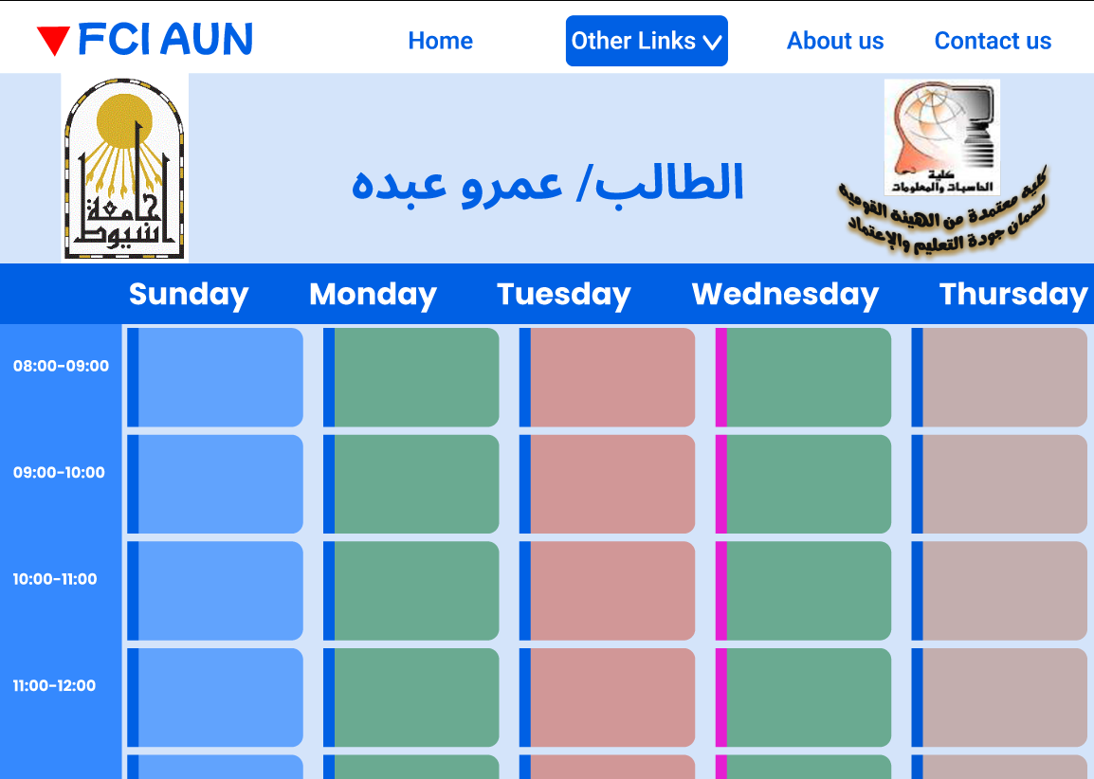

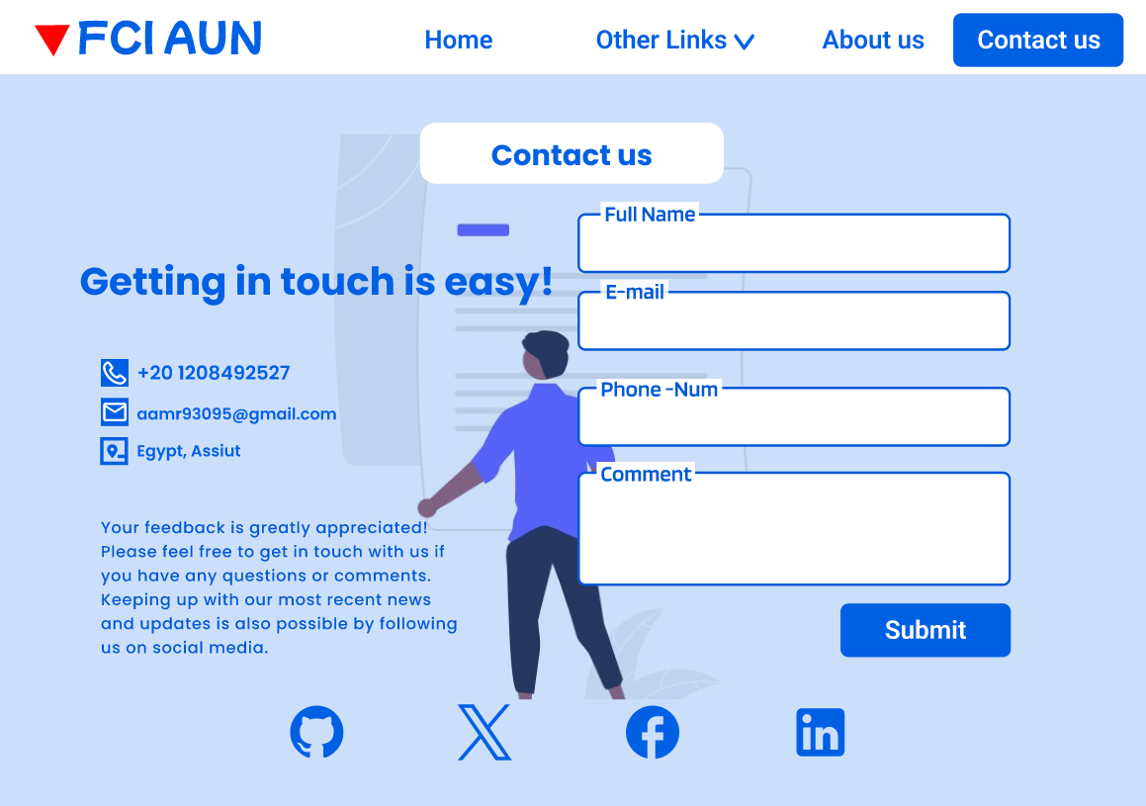

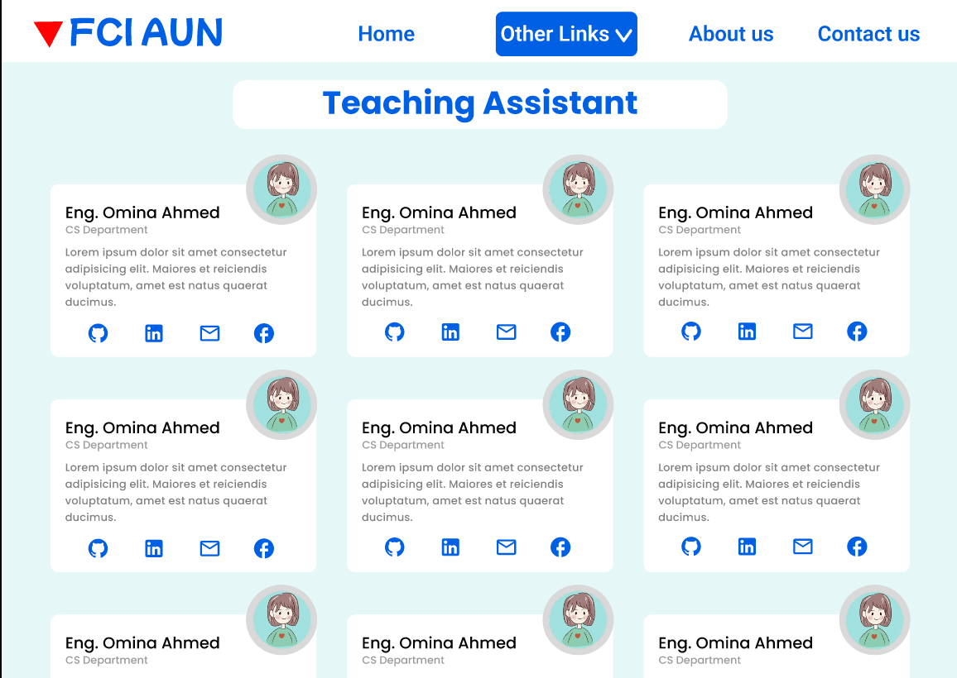

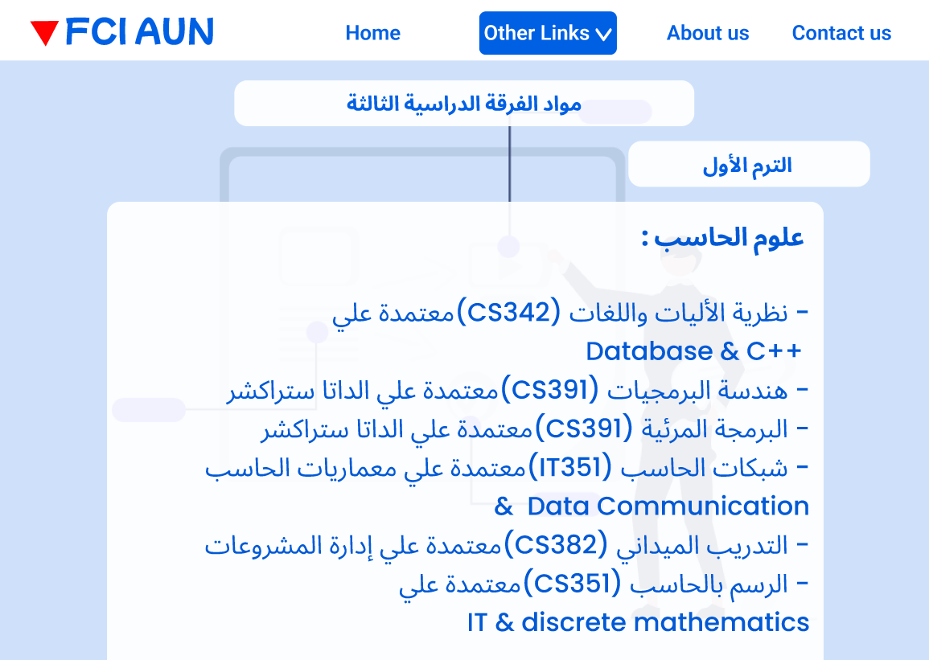

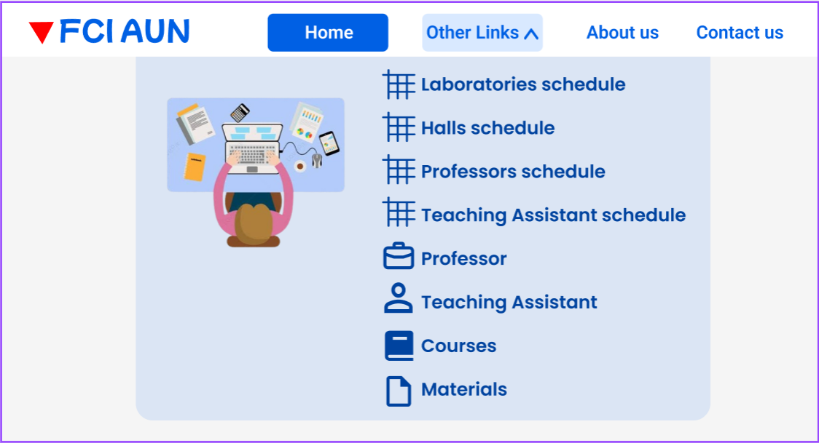

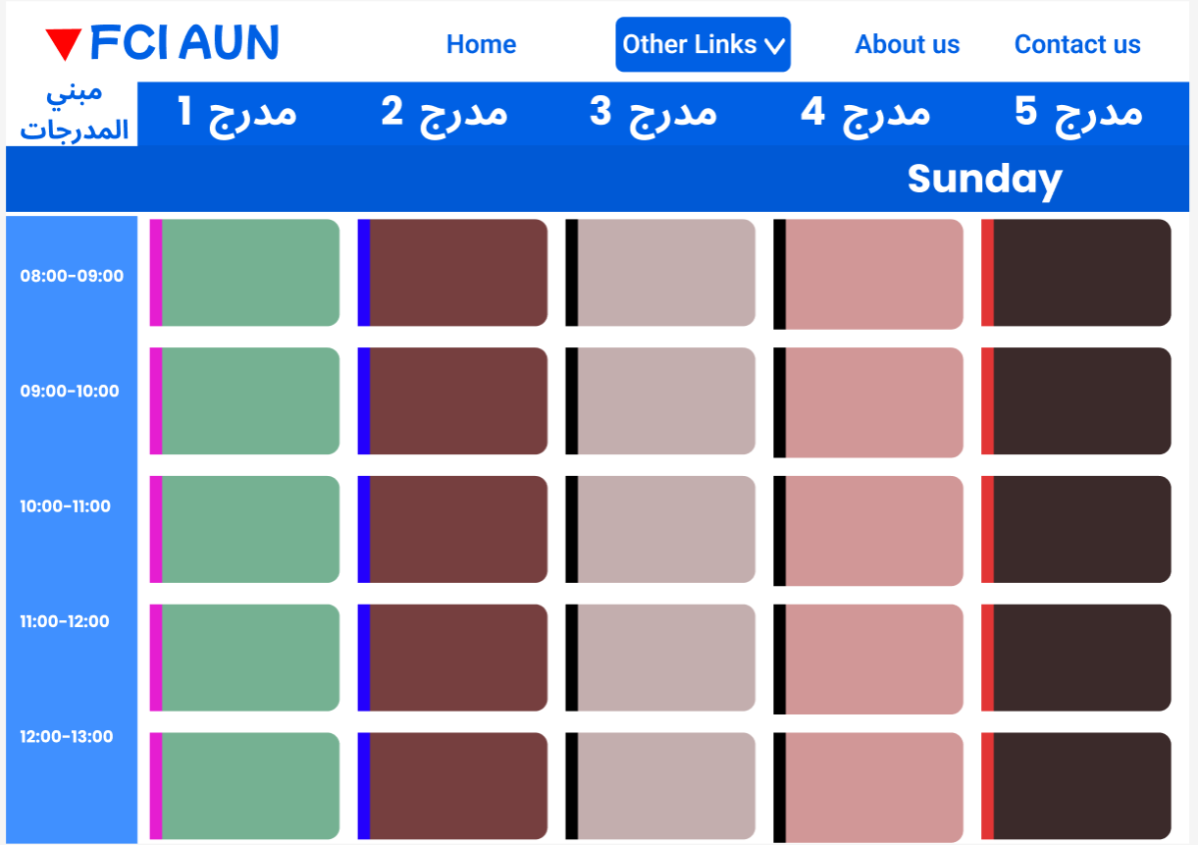

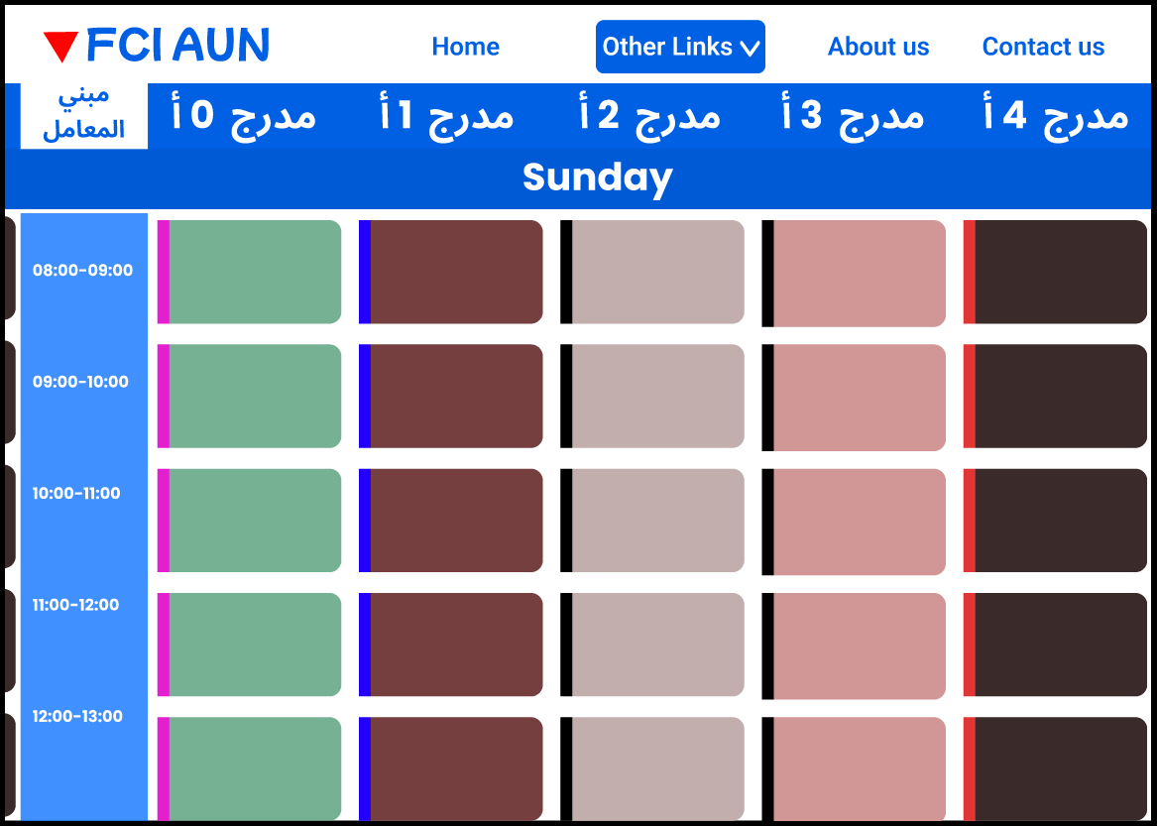

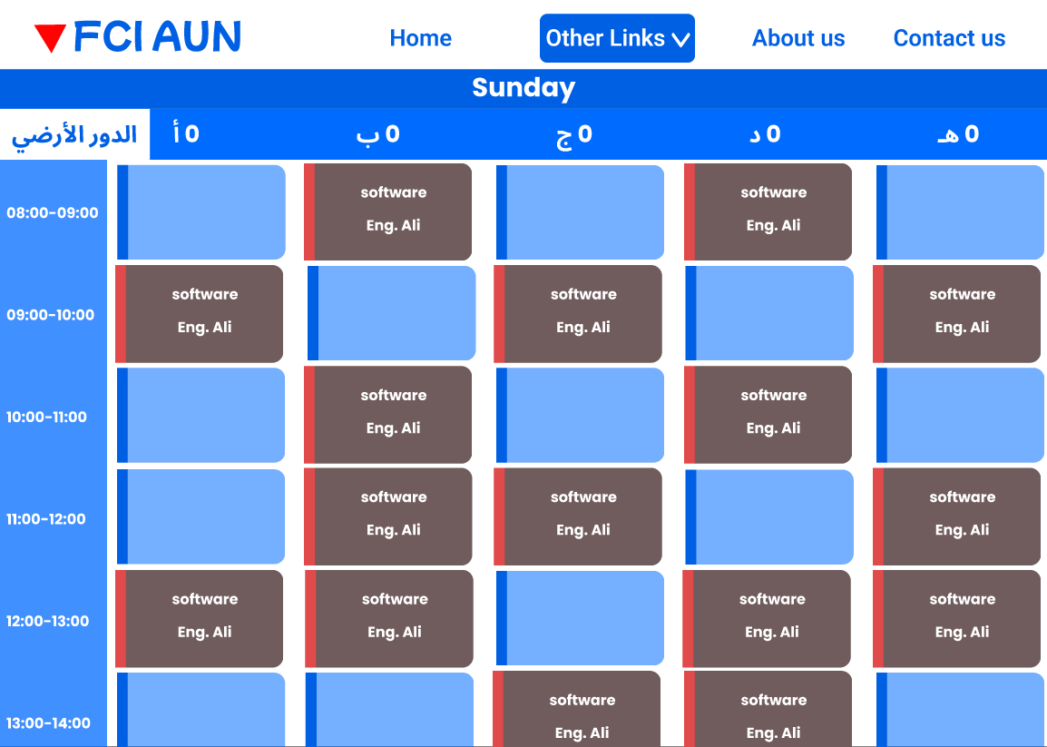

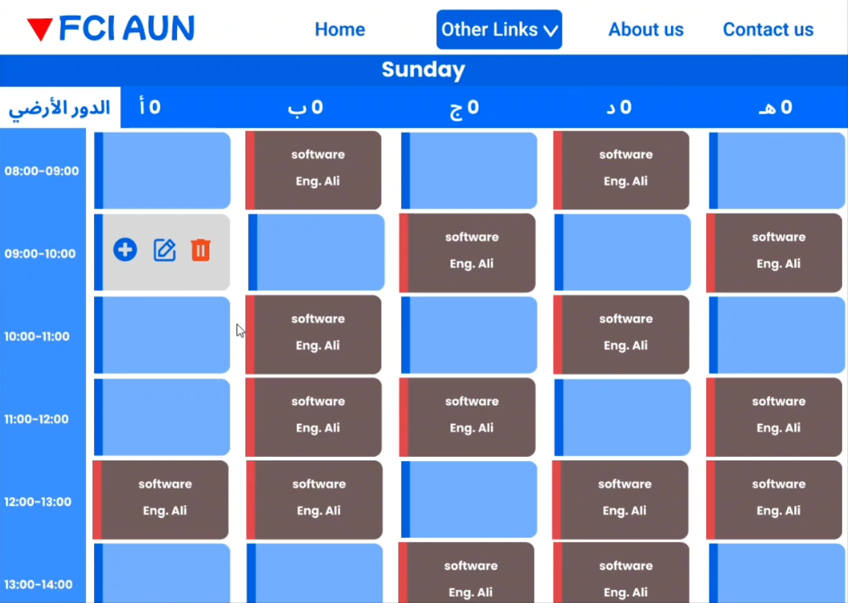

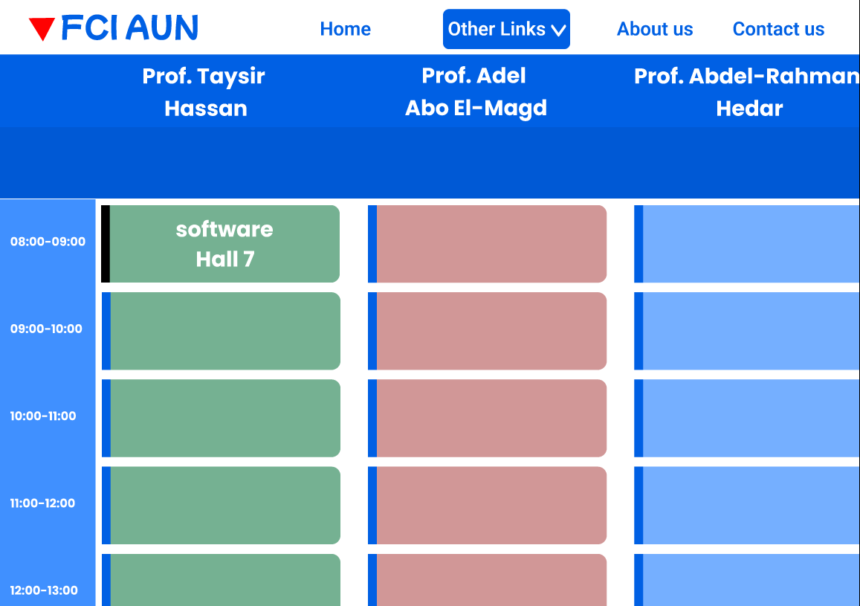

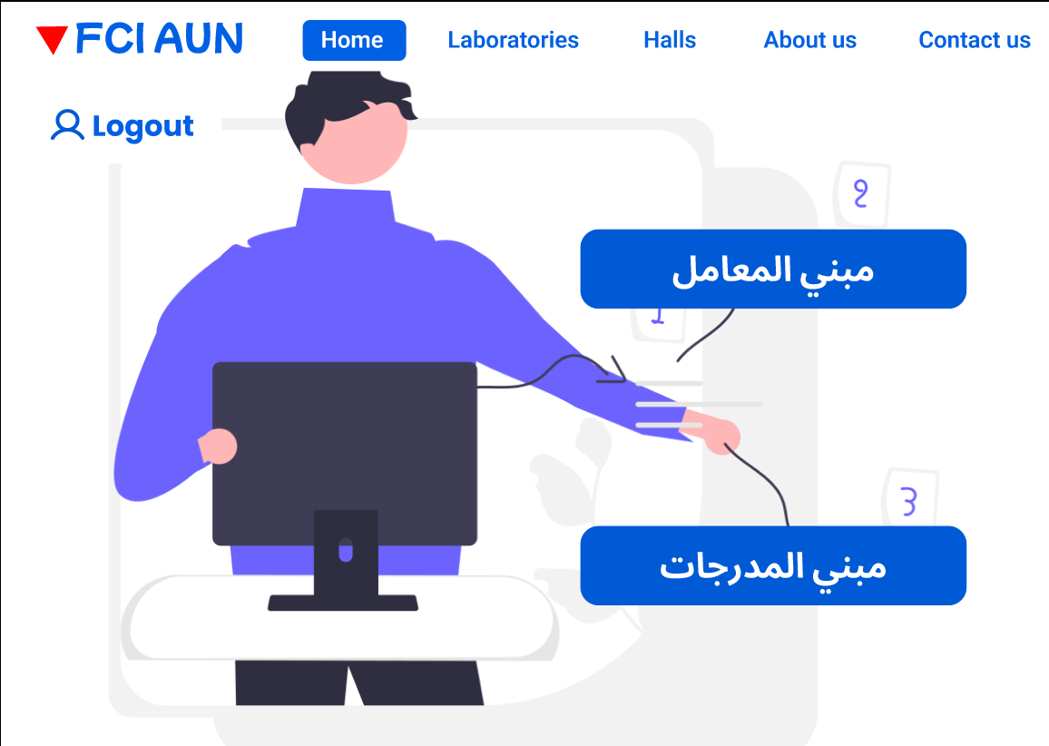


A screenshot of a computer

## 6.2 Hardware Interfaces

Hardware interfaces in the context of a centralized college information system typically refer to the physical connections and interactions between the software system and the hardware components it relies on. Here are some key hardware interfaces to consider:

Servers:

Specify the hardware requirements for the servers hosting the Web site. This includes details such as processor specifications, memory (RAM), storage capacity (hard disk space), and network interfaces.

Database Server:

Outline the hardware specifications for the server hosting the database management system (DBMS). Consider factors such as disk I/O, memory, and processing power to ensure efficient database operations. The hardware interfaces will be designed to be compatible with a variety of hardware configurations and operating systems. The system will be optimized for performance.

## 6.3 Software Interfaces

1- We have developed an initial design prototype using Figma to improve the user experience and simplify navigation within the website, with the goal of providing users with information more easily.

2- We Use .Net + Database +HTML + CSS + JavaScript using React.js by Visual studio code.

3- MySQL server - Database connectivity and management

## 6.4 Communications Interfaces

1- NIC (Network Interface Card) – It is a computer hardware component that allows a computer to connect to a network. NICs may be used for both wired and wireless connections.

2- CAT 6 network cable- for high signal integrity.

3- TCP/IP protocol- Internet service provider to access and share information over the Internet.

4- Ethernet Communications Interface- Ethernet is a frame-based computer network technology for local area networks (LANs).

Ubiquitous, easy to set up and easy to use. Low cost and high data transmission rate

# 7. System Features

## 7.1 Function Requirement

|  |  |
| --- | --- |
| Function One | Login |
| Input | National number and password. |
| Processing | Check if the National number and password is valid in the database, then retrieve specific Views. |
| Output | Home page containing specific Views. |

|  |  |
| --- | --- |
| Function Two | About Us |
| Input | No input. |
| Processing | Retrieve all information about us from data base. |
| Output | A view containing some information about the about us. |

|  |  |
| --- | --- |
| Function Three | Contact Us |
| Input | Full name, E-mail, Phone number, and message. |
| Processing | Validate the entered data then add it to database. |
| Output | Message added or not, then view new contact us. |

|  |  |
| --- | --- |
| Function Four | Admission for new student. |
| Input | All details needed for a new student like name, date of birth and more details. |
| Processing | Validate data then store it in database. |
| Output | Message added or not, then view same home page. |

|  |  |
| --- | --- |
| Function Five | View material for all semesters. |
| Input | No input. |
| Processing | Retrieve all semesters google drive link from level 1 to 4 and all departments from the databases |
| Output | A view that contains all semesters and their departments and click on any of them to go to google drive link. |

|  |  |
| --- | --- |
| Function Six | View courses for all modules. |
| Input | No input. |
| Processing | Retrieve all Courses details from level 1 to 4 from the databases |
| Output | A view that contains all Courses details. |

|  |  |
| --- | --- |
| Function Seven | View student, professor, or teaching assistant schedule. |
| Input | National number for one module. |
| Processing | Retrieve all lectures and all sessions details like time, day, and place from database. |
| Output | A view that contains schedule for the current module containing lectures and session details. |

|  |  |
| --- | --- |
| Function Eight | View professors. |
| Input | No input. |
| Processing | Retrieve all professors’ details needed from database. |
| Output | A view that contains all professors and their details. |

|  |  |
| --- | --- |
| Function Nine | View teaching assistants. |
| Input | No input. |
| Processing | Retrieve all Teaching-assistants details needed from database. |
| Output | A view that contains all Teaching-assistants and their details. |

|  |  |
| --- | --- |
| Function Ten | View Laboratory. |
| Input | Laboratory id. |
| Processing | Retrieve all details for the lab from database. |
| Output | View containing all details for the lab like devices status and details. |

|  |  |
| --- | --- |
| Function Eleven | View Hall. |
| Input | Hall id. |
| Processing | Retrieve all details for the Hall from database. |
| Output | View containing all details for the Hall like devices status and details. |

|  |  |
| --- | --- |
| Function Twelve | Laboratories schedule for admin. |
| Input | No input. |
| Processing | Retrieve all laboratories details from database. |
| Output | View Schedule for all laboratories containing session place, time, teaching-assistant name, and name of the course. |

|  |  |
| --- | --- |
| Function Thirteen | Halls schedule for admin. |
| Input | No input. |
| Processing | Retrieve all Halls details from database. |
| Output | View Schedule for all Halls containing Lecture place, time, professor name, and name of the course. |

|  |  |
| --- | --- |
| Function Fourteen | Professors schedule for admin. |
| Input | No input. |
| Processing | Retrieve all professor’s details from database. |
| Output | View Schedule for all professors containing Lecture place, time, professor name, and name of the course. |

|  |  |
| --- | --- |
| Function Fifteen | Teaching-assistants schedule for admin. |
| Input | No input. |
| Processing | Retrieve all Teaching-assistant’s details from database. |
| Output | View Schedule for all Teaching-assistants containing session place, time, professor name, and name of the course. |

## 7.2 Non-Function Requirement

### 7.2.1 Performance requirements

Response time: The system will give responses within 1 second after checking the patient information and other information.

Capacity: The system must support 1000 people at a time.

User interface: User interface screen will response within 5 seconds.

### 7.2.2 Safety requirements

If there is extensive damage to a wide portion of the database due to catastrophic failure, such as a disk crash, the recovery method restores a past copy of the database that was backed up to archival storage and reconstructs a more current state by reapplying or redoing the operations of committed transactions from the backed-up log, up to the time of failure. All the administrative and data entry operators have unique logins so the system can understand who login is into system right now no intruders allowed except system administrative nobody can’t change record and valuable data.

### 7.2.3 Security requirements

1- Want to take responsibility for failures due to hardware malfunctioning.

1. The warranty period for maintaining the software would be one year.
2. Additional payments will be analyzed and charged for further maintenance.
3. If any error occurs due to a user’s improper use. The warranty will not be allocated to it.
4. No money back returns for the software.

### 7.2.4 Software System Attribute

1- Usability: Software can be used again and again without distortion.

2- Availability: The system shall be available all the time.

3- Correctness: Bug free software which fulfills the correct need/requirements of the client.

4- Maintainability: The ability to maintain, modify information and update fix problems of the system.

1. Accessibility: Administrator and many other users can access the system, but the access level is controlled for each user according to their work scope.

## 7.3 Data Base Tables

### 7.3.1 Tables

1- Student

2- Professor

3- Teaching assistant

4- IT technical

1. Prerequisite

6- Course

7- Halls

8- Laboratories

9-Devices

### 7.3.2 Tables Mata Data

**1- Student**

1. Personal Information:

- Full Name

- Date of Birth

- Gender

- Nationality

- Contact Information (address, phone number, Academic

mail)

2. Identification Information:

- Student ID

- Social Security Number (or equivalent)

3. Enrollment Information:

- Enrollment Date

- Graduation Date (expected or actual)

- Academic Program or Major

- Class/Grade Level

4. Academic Performance:

- Grades

- GPA (Grade Point Average)

**2- Professor**

1. Personal Information:

- Full Name

- Date of Birth

- Gender

- Contact Information (address, phone number, email)

2. Identification Information:

- Professor ID

- Social Security Number (or equivalent)

3. Academic Information:

- Academic Background (degrees, major, graduation date)

4. Employment Information:

- Department

5. Teaching Information:

- Courses Taught

- Course Schedule

6. Contact Information for Students:

- Office Location

- Office Hours

**3- Teaching Assistant (TA)**

1. Personal Information:

- Full Name

- Date of Birth

- Gender

- Contact Information (address, phone number, email)

2. Identification Information:

- Teaching Assistant (TA) ID

- Social Security Number

3. Academic Information:

- Academic Background (degrees, major, graduation date)

4. Employment Information:

- Department

- Contract Start and End Dates

10. Contact Information for Students:

- Office Hours

- TA's Location or Office Room

**4- IT technical**

1. Personal Information:

- Full Name

- Date of Birth

- Gender

- Contact Information (address, phone number, email)

2. Identification Information:

- Employee ID or IT ID

- Social Security Number (or equivalent)

3. Professional Information:

- Job Title (e.g., IT Technician, Systems Administrator,

Network Engineer)

4. Educational Background:

- Degrees

- Certifications

- Relevant Courses

5. Work Experience:

- Previous Employment History

- Relevant Projects

6. Job Responsibilities:

- Detailed description of job duties and responsibilities

**5- Prerequisites**

* Course ID
* Course Prerequisites ID

**6- Course**

1. Course Details:

- Course Title

- Course Code (Course ID)

- Department Offering the Course

- Description of the Course

- Prerequisites

2. Credit Hours:

- Number of Credits

- Credit Hours

**7- Halls**

1. Hall Identification:

- Hall Name

- Hall Code or ID

- Location (Building, Room Number or Address)

**8- laboratories**

1. Lab Identification:

- Lab Name

- Lab Code or ID

- Location (Building, Room Number)

- Lab Technicians

**9- Devices**

1. Device Identification:

- Device Name

- Serial Number (ID)

- Device Model

- Unique Device Identifier (UDID)

2. Location Information:

- Current Location (room, building, site)

- Assigned Location or User

4. Configuration and Specifications:

- Hardware Specifications (processor, RAM, storage, GPU)

- Operating System

- Software Installed

15. Device Status:

- Operational Status (active, inactive, in repair)

**10- Semester**

- Semester ID (Primary Key)

- Academic Year

- Level

- Google Drive Link

- Department Id

- Term Type (Fall, Spring, or Summer)

**11- Department**

-Department ID (Primary Key)

-Department Name

-Head of Department

## 7.4 ERD Diagram

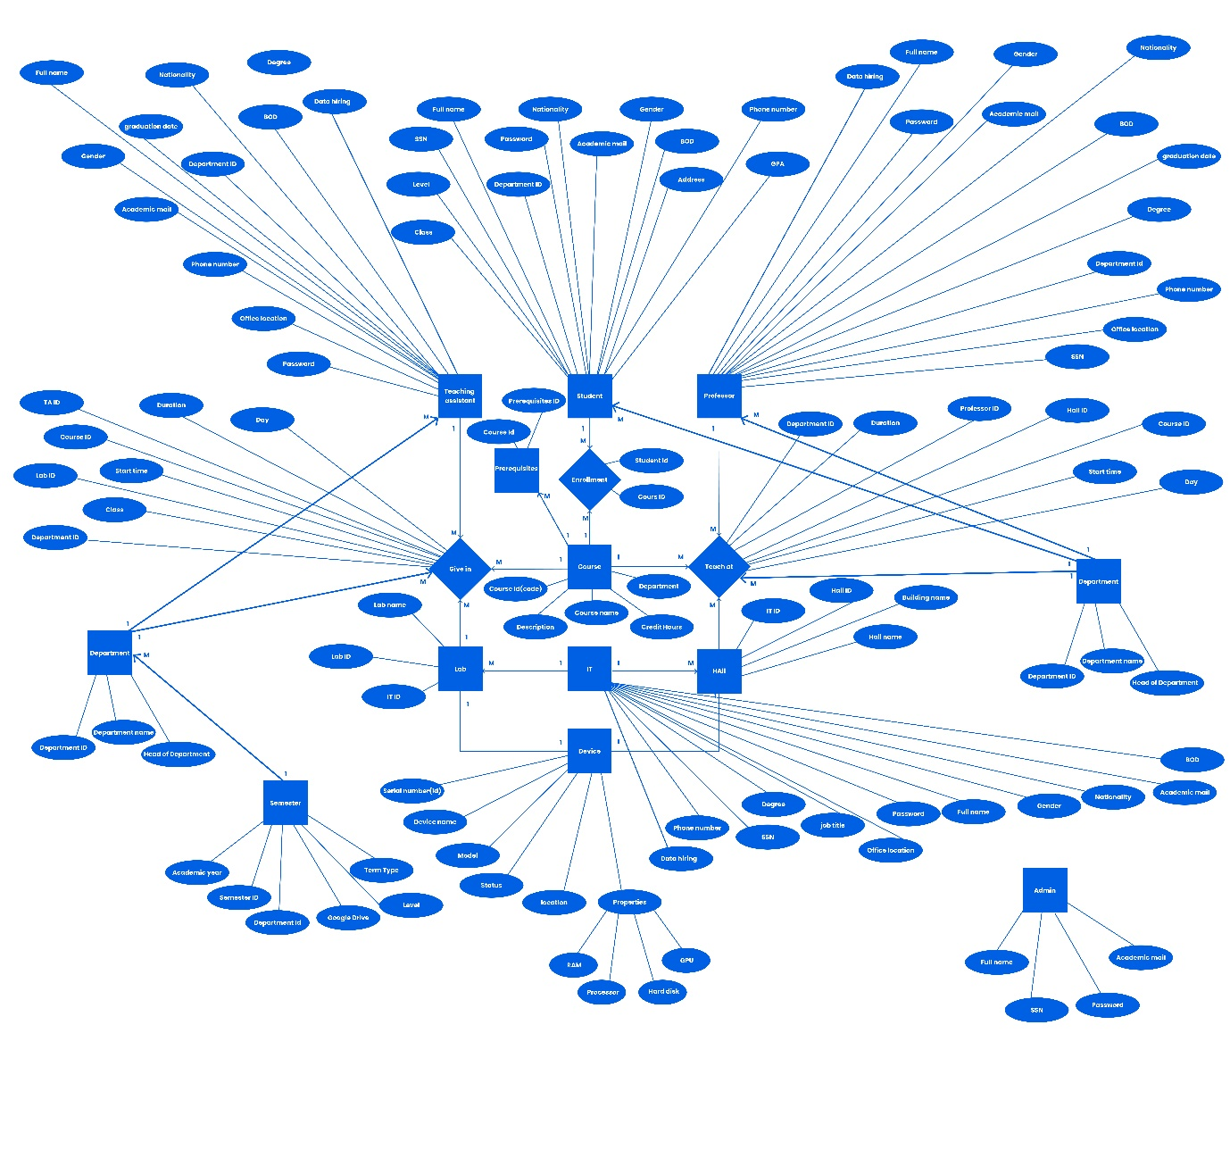

## 7.5 Use Case Diagram

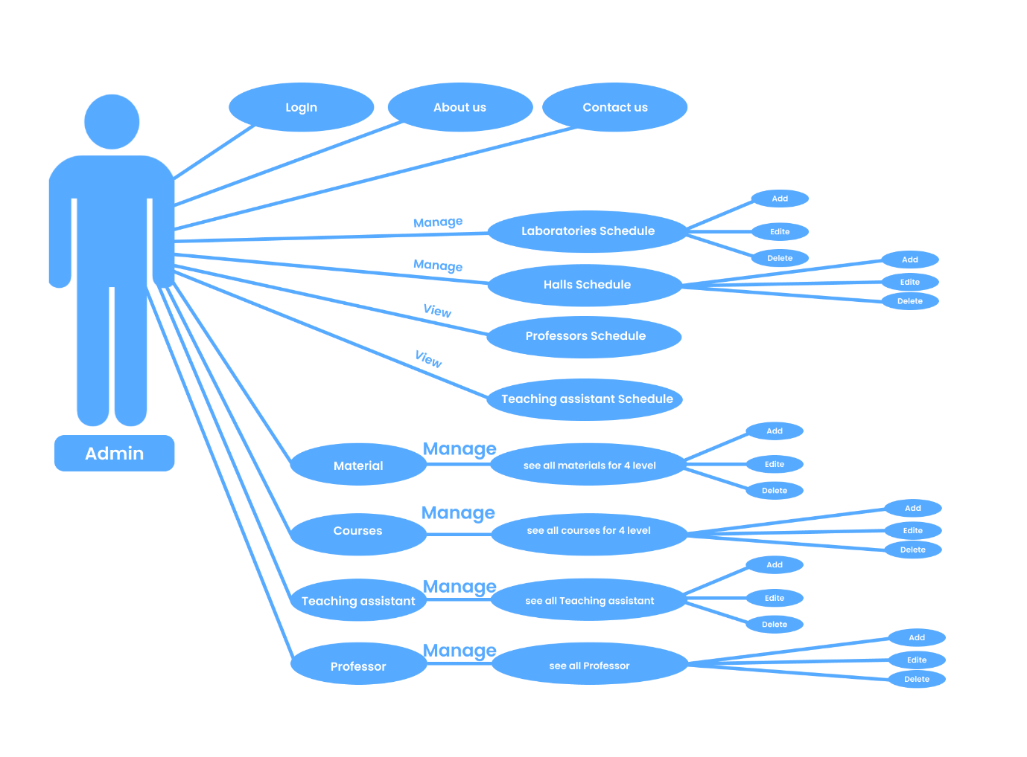

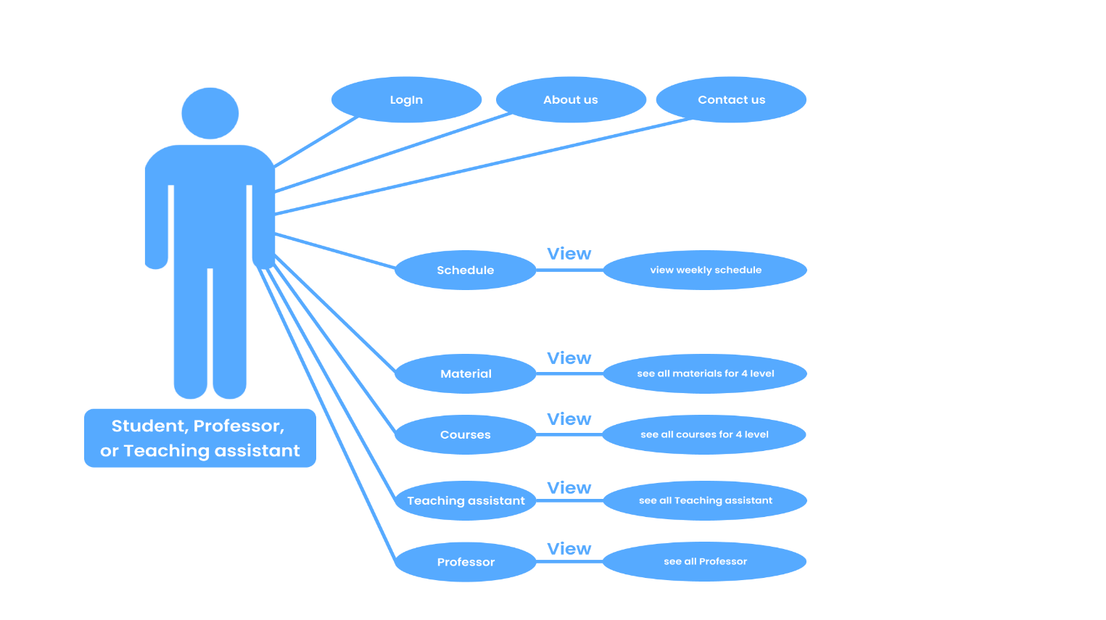

## 7.6 Use Case scenario

laboratories schedule for admin.

|  |  |  |
| --- | --- | --- |
| laboratories schedule for admin. | | Use case name |
| Display the laboratories schedule for the admin can update, delete, or add lab appointments. | | Goal |
| Admin | | Actor |
| 1-The administrator must be logged into the system to access the parameter table.  2-The administrator must have the necessary permissions to access the parameter table. This includes reading, writing, and modify permissions.  3-The system must be in proper operating condition and ready to receive requests from the administrator. | | Precondition |
| 1-After viewing the parameter table, the data must have been properly updated in the database, and these updates can include adding new information or modifying existing information.  2-There can be a confirmation or success message displayed to the administrator after the parameter table display process is successful. | | Postcondition |
| Action | Step | Main flow |
| system checks if he is admin whether it is valid or not. | 1- |
| The home page will appear, and the admin will choose the labs. | 2- |
| system receive request and display a schedule of all laboratories with their dates for the admin. | 3- |
| if admin wants to update, he Hover on cell then choose update. | 4- |
| system receive request then show all details of the selected cell in the schedule. | 5- |
| admin update data then click on update button. | 6- |
| system receive update then check if it is correct, he Update it in the database else he Display an error message and go to same page for update | 7- |
| If he adds a host, he Hover on cell then choose "add". | 8- |
| system receive request then show form for addition. | 9- |
| admin fill in the required information then click "add". | 10- |
| system receive request for addition then check if the data is correct, he adds it in the database else he displays an error message and go to same page for addition. | 11- |
| In case of deletion, he Hover on cell then choose "delete". | 12- |
| system receive request and display a confirmation message will appear if true system delete it from database otherwise, he cancels request. | 13- |

Hall schedule for admin.

|  |  |  |
| --- | --- | --- |
| Hall schedule for admin. | | Use case name |
| Display the Hall schedule for the admin and he can update, delete, or add lab appointments. | | Goal |
| Admin | | Actor |
| 1-The administrator must be logged into the system to access the parameter table.  2-The administrator must have the necessary permissions to access the parameter table. This includes reading, writing, and modify permissions.  3-The system must be in proper operating condition and ready to receive requests from the administrator. | | Precondition |
| 1-After viewing the parameter table, the data must have been properly updated in the database, and these updates can include adding new information or modifying existing information.  2-There can be a confirmation or success message displayed to the administrator after the parameter table display process is successful.  3-the operations performed by the administrator are recorded. | | Post-condition |
| Action | Step | Main flow |
| system checks if he is admin whether it is valid or not. | 1- |
| The home page will appear, and the admin will choose the Halls. | 2- |
| system receive request and display a schedule of all Halls with their dates for the admin. | 3- |
| if admin wants to update, he Hover on cell then choose "update". | 4- |
| system receive request then show all details of the selected cell in the schedule. | 5- |
| admin update data then click on "update" button. | 6- |
| system receive update then check if it is correct, he Update it in the database else he Display an error message and go to same page for update | 7- |
| If he adds a host, he Hover on cell then choose "add". | 8- |
| system receive request then show form for addition. | 9- |
| admin fill in the required information then click "add". | 10- |
| system receive request for addition then check if the data is correct, he adds it in the database else he displays an error message and go to same page for addition. | 11- |
| In case of deletion, he Hover on cell then choose "delete". | 12- |
| system receive request and display a confirmation message will appear if true system delete it from database else, he cancels request. | 13- |

Professor schedule for admin.

|  |  |  |
| --- | --- | --- |
| Professors schedule for admin. | | Use case name |
| Display the Professors schedule for the admin. | | Goal |
| Admin | | Actor |
| 1-The administrator must be logged into the system to access the parameter table.  2-The administrator must have the necessary permissions to access the parameter table.  3-The system must be in proper operating condition and ready to receive requests from the administrator. | | Precondition |
| 1-After viewing the parameter table, the data must have been properly updated in the database.  2-There can be a confirmation or success message displayed to the administrator after the parameter table display process is successful.  3-the operations performed by the administrator are recorded. | | Post-condition |
| Action | Step | Main flow |
| system checks if he is admin whether it is valid or not. | 1- |
| The home page will appear, and the admin will choose the professor. | 2- |
| system receive request and displays a schedule of all professors with their dates for the admin. | 3- |

Teaching-assistants schedule for admin.

|  |  |  |
| --- | --- | --- |
| Teaching assistants schedule for admin. | | Use case name |
| Display the Teaching assistants schedule for the admin. | | Goal |
| Admin | | Actor |
| 1-The administrator must be logged into the system to access the parameter table.  2-The administrator must have the necessary permissions to access the parameter table.  3-The system must be in proper operating condition and ready to receive requests from the administrator. | | Precondition |
| 1-After viewing the parameter table, the data must have been properly updated in the database.  2-There can be a confirmation or success message displayed to the administrator after the parameter table display process is successful.  3-the operations performed by the administrator are recorded. | | Post-condition |
| Action | Step | Main flow |
| system checks if he is admin whether it is valid or not. | 1- |
| The home page will appear, and the admin will choose the Teaching assistants. | 2- |
| system receive request and displays a schedule of all Teaching assistants with their dates for the admin. | 3- |

|  |  |  |
| --- | --- | --- |
| View schedule for users. | | Use case name |
| View student, professor, or teaching assistant schedule. | | Goal |
| Student, Professor, or Teaching assistant. | | actor |
| 1-The actor has a valid national ID.  2-If the actor enters incorrect credentials, the system displays an error message, prompting the actor to enter the correct information. | | Precondition |
| 1-The student is successfully logged in.  2-The students have accessed and viewed their weekly timetable.  3-The student can navigate to other sections or log out. | | Post-condition |
| Action | Step | Main flow |
| Users select schedule button. | 1 |
| System receives request. | 2 |
| System gets all dates of sessions and their details from database. | 3 |
| View all dates of lectures or sessions and their details for the current user. | 4 |

View schedule for users.

View courses.

|  |  |  |
| --- | --- | --- |
| View courses. | | Use case name |
| View the courses of every semester and their dependencies with each other. | | Goal |
| Student, Professor, Teaching-assistant, and Admin. | | actor |
| 1-The user must be authenticated and have the necessary permissions to access the courses.  2-System must have all courses stored in the database, categorized by semester. | | Precondition |
| The user can access the courses related to the selected semester. | | Post-condition |
| Action | Step | Main flow |
| The system shows list of semesters. | 1 |
| The user selects the desired semester from a list of available semesters. | 2 |
| The system retrieves the courses names associated with the selected semester. | 3 |
| The user directly goes to the courses page where the courses are listed. | 4 |
| If the system has no data for the selected semester, he displays a message indicating that there are no courses available for the selected semester. | 5 |

View materials.

|  |  |  |
| --- | --- | --- |
| View materials. | | Use case name |
| View the google drive links for materials related to a specific semester or a department. | | Goal |
| Student, Professor, Teaching-assistant, and Admin. | | actor |
| 1-The user must be authenticated and have the necessary permissions to access the materials.  2-System must have the google drive links stored in the database, categorized by semester and department. | | Precondition |
| The user can access the google drive links for materials related to the selected semester or the department. | | Post-condition |
| Action | Step | Main flow |
| The system shows list of semesters and departments. | 1 |
| The user selects the desired semester or the department from a list of available semesters and departments. | 2 |
| The system retrieves the Google Drive links associated with the selected semester or the department from the database. | 3 |
| The user directly goes to google drive link. | 4 |
| If the system has no link for the selected semester or the department, he displays a message indicating that there is no material available for the selected semester or the department. | 5 |

View Laboratory for IT.

|  |  |  |
| --- | --- | --- |
| View Laboratory. | | Use case name |
| View all details for the selected laboratory and update their state. | | Goal |
| IT or IT technician. | | actor |
| 1-The IT technician has a valid national ID.  2- If the IT technician enters incorrect credentials, the system displays an error message, prompting them to enter the correct information. | | Precondition |
| 1-The IT technician is successfully logged in.  2-The IT technician has accessed detailed information about the equipment in a specific laboratory. | | Post-condition |
| Action | Step | Main flow |
| IT-technician select laboratories button. | 1 |
| System receive request. | 2 |
| System shows all laboratories. | 3 |
| The IT-technician selects the desired lab from a list of available Laboratories. | 4 |
| System receive request then get details for the related lab from database. | 5 |
| System shows all details related to the selected lab | 6 |
| IT-technician can update devices state by clicking on the device, the red color mean device is unavailable, yellow mean device is in repairing, green mean device is working. | 7 |
| The system receives the update state then update it in the database. | 8 |

View Hall for IT.

|  |  |  |
| --- | --- | --- |
| View Hall | | Use case name |
| View all details for the selected hall and update their state. | | Goal |
| IT or IT technician | | Actor |
| 1- The IT technician has a valid national ID.  2- If the IT technician enters incorrect credentials, the system displays an error message, prompting them to enter the correct information. | | Precondition |
| 1- The IT technician is successfully logged in.  2- The IT technician has accessed detailed information about the equipment in a specific hall. | | Post-condition |
| Action | Step | -Main flow |
| IT-technician select hall button. | 1- |
| System receive request. | 2- |
| System shows all halls. | 3- |
| The IT-technician selects the desired hall from a list of available Halls. | 4- |
| System receives request then get details for the related hall from database. | 5- |
| System shows all details related to the selected hall. | 6- |
| IT-technician can update devices state by clicking on the device, the red color mean device is unavailable, yellow mean device is in repairing, green mean device is working. | 7- |
| The system receives the update state then update it in the database. | 8- |

## 7.7 Activity Diagram

laboratories schedule for admin.

|  |  |
| --- | --- |
| System | Admin |
| Receive Request      Receive Request    Receive Request    check    Yes  No  Update or add it in DB    Receive request and Delete cell from DB | Choose Labs  Show Schedule for all labs  Select cell     |  | | --- | |  |   Select Delete  Select update  Select add  Show all details      Update data or add new data  Show the same page with the entered data with error message  Delete  No  Yes  Cancel Request |

Hall schedule for admin.

|  |  |
| --- | --- |
| System | Admin |
| Receive Request      Receive Request    Receive Request    check    Yes  No  Update or add it in DB    Receive request and Delete cell from DB | Choose Halls  Show Schedule for all halls  Select cell     |  | | --- | |  |   Select Delete  Select update  Select add  Show all details      Update data or add new data  Show the same page with the entered data with error message  Delete  No  Yes  Cancel Request |

Professor schedule for admin.

|  |  |
| --- | --- |
| System | Admin |
| Receive request  Found  Not found  Check | Show schedule for all professors  Choose professors  Show home page  Invalid Message  Log in system |

Teaching-assistants schedule for admin.

|  |  |
| --- | --- |
| System | Admin |
| Receive request  Found  Not found  Check | Choose Teaching-assistants  Show schedule for all Teaching-assistants  Show home page  Invalid Message  Log in system |

View schedule for users.

|  |  |
| --- | --- |
| System | Student, professor, or teaching assistant |
| gets all dates of Lectures and their details from database  receives request | View all dates of sessions and their details  select schedule button |

View courses.

|  |  |
| --- | --- |
| System | User |
| Display message “Doesn’t exists for the current time”  Show all semesters  Not found  Check  Receive request | Go to the course page  Select semester  Found |

View materials.

|  |  |
| --- | --- |
| System | User |
| Not found  Display message “Not exists for the current time”  Check  Receive request  Show all semesters and departments | Found  Go to google drive  Select semester or department |

View Laboratory for IT.

|  |  |
| --- | --- |
| System | IT or IT technician |
| Receive request and update state  Receive request  Receive request | View all details related to the selected lab  Change state of a device  Update state of a device  Select Lab  View all laboratories  Select laboratories button. |

View Hall for IT.

|  |  |
| --- | --- |
| **System** | IT |
| Receive request and update state  Receiver request  Receive request | select hall button  Change state of a device  Update state of a device  View all details related to the selected lab  Select Hall  View all Halls |

# 8. Other Nonfunctional Requirements

## Performance Requirements

1-The system must respond to the business operation in less than 3 seconds for user (admin).

2-The system should be compatible with all modern browsers.

3-The system should respond to the operation messages to the users within 2 seconds.

4-The system should be reliable.

5-Fast loading times: Ensuring that the website loads quickly to provide a seamless user experience and prevent users from getting frustrated or abandoning the site

6- The schedules of teaching assistants must be updated, and the information must be up-to-date and accurate to avoid confusion and confusion between students and academic members

7- Reliability and uptime: Ensuring that the website is always available and accessible to users, minimizing downtime and server errors.

## Safety Requirements

1- The system must handle safe login and logout through session.

2- Data reading techniques and information authentication methods should be used to address portfolios and especially the privacy and security of student archives.

3- Secure backup and disaster recovery:

Implementing regular backups of the website's data and having a disaster recovery plan in place to ensure that data can be restored in the event of a system failure or cyberattack.

4- Using the HTTPS protocol and translating communications between the user and the server.

5- Implement strong authentication measures such as strong passwords and two-factor verification.

6- Updating the programs and systems of the Security Lion character.

7- Evaluate the internal system and find any specific smartphone.

8- Providing the correct access permissions for each user according to them in the project.

9- Train users on best practices in data security and privacy.

## 8.3 Security Requirements

1- Secure user authentication: Implementing strong password policies, multi-factor authentication, and secure login mechanisms to ensure only authorized users can access the website.

2- Secure communication: Implementing secure protocols such as HTTPS to encrypt communication between the website and users' browsers, ensuring data integrity and confidentiality.

3- The database should be secured from SQL injection to prevent leakage or loss of information.

4- Personal protection: Student data must be protected and unauthorized access must not be allowed.

5- Define permissions: The access permissions of different users must be defined, except for the absence of incorrect feedback.

6- Activity Monitoring: A monitoring system must be provided to record and track activities in the system to identify any unauthorized activity.

7- Updating software and systems: Continuous security updates must be provided for the software and systems used in the student schedule display project to ensure their safety from security threats.

8- Providing a backup system: A backup system must be provided for data to ensure its recovery in the event of any accident that leads to its loss.

## 8.4 Software Quality Attributes

1- The system should be reliable and consistently available, aiming for at least 99.8% uptime.

2- The system should respond to user interactions within 5 seconds on average, even during peak usage times.

3- The system should be designed to handle a growing number of users and data without a significant drop in performance.

4- The system should comply with accessibility standards to ensure that it is usable by individuals with disabilities.

5- The codebase should be well-organized and well-commented to facilitate future updates and maintenance.

6- The system should provide clear and informative error messages to guide users in case of unexpected events.

7- The system should undergo thorough load testing to ensure it can handle many concurrent users without performance degradation.

8- Security: The system must be protected from security threats and

cyber-attacks to ensure the safety of data and information.

9- Responsiveness: The system must be able to deal with errors and problems effectively and quickly to ensure service continuity.

10- Scalability: The system must be able to be expanded and developed to keep pace with the needs of the university and changes in the presentation of student schedules.

11- Reliability: The system must be reliable and stable to ensure that the service is not interrupted, and that data is always available.

12- Compatibility: The system must be compatible with the various systems and technologies used at the university to ensure its integration with the rest of the systems.

## 8 .5 Business Rules

1- The system must have the ability to display accurate and up-to-date comprehensive schedules.

2- Data must be requested by the system reliably.

3- Comprehensive review methodologies must be updated for changes in Faculty schedules.

4- It must have a system dedicated to specialty data and not allow any unauthorized person to access it.

5- Means shall be provided to correct any error in ice tables quickly and effectively.

6- The system must generally browse university colleagues and students.

# 9. Other Requirements

1- Compatibility and Browser Support: Design the system to be responsive and accessible on various devices (desktops, mobile phones).

2- Error Handling: Provide clear and informative error messages to guide users in case of unexpected situations.

3- Security: ensure that all sensitive data is encrypted during transit and utilize strong authentication mechanisms to verify user identities.

4- Software Updates: Plan for regular updates and patches to address bugs, security vulnerabilities, and feature enhancements.

5- Technical Support: Provide a support system for users to report issues and seek assistance.

6- An easy-to-use user interface must be provided to enter and update student data.

7- The system must have the ability to generate reports and statistics about student schedules to assist the administration in making decisions.

8- A notification system must be provided to alert students and staff about any changes in student schedules.

9- The system must have the ability to integrate with other systems at the university, such as the student management system and human resources.

10- An Application Programming Interface (API) must be provided to allow integration with other external applications.

11- The system must have the ability to store and manage students’ personal information securely and in compliance with data protection laws.

12- An access permission management system must be in place to ensure that only authorized persons can access student data.

13- The system must have the ability to track students’ attendance and academic performance.

14- A system must be provided to manage classrooms and distribute students based on their study schedules.

# 10. Revision History

|  |  |  |
| --- | --- | --- |
| **Day** | **Date** | **Description** |
| **Thursday** | **7/ 12/ 2023**  **(Offline)** | The ideas and how the site works were discussed with the doctor and teaching assistant, and an idea was agreed upon (FSSIS) |
| **Friday** | **15/ 12/ 2023**  **(Online)** | We talked about:  1-modules and the relationship between them  2-featueres We can add it  3-We talked about specific features things like:  a-The professor can provide the courses and grades and the student can see them.  b-The student can see the information provided by the professor and teaching assistant. |
| **Monday** | **8 / 1 / 2024**  **(Offline)** | The conversation includes discussing how to create a complete schedule, starting from the initial creation of the timetable, and gathering feedback from professors for courses at all academic levels. Then, creating a specific timetable for each professor. Afterward, a dedicated schedule for teaching assistants was developed, incorporating all the relevant appointments.    Then, dividing the class into sections and distributing them across laboratories based on the available equipment capabilities for each scientific subject.  There is a schedule for each professor, a schedule for each teaching assistant,  a schedule for each laboratory, and a schedule detailing the capabilities of the devices available in each lab.  We spoke with Student Affairs, and they requested a page for submitting college enrollment applications. This page should include all necessary information about the student.  Engineer Ahmed Maher:  - The number of devices in the lab is 25.  - Specialized labs mostly contain cameras and are located on the first floor.  - Small labs from (B) to (H) have 2 air conditioners, while large labs (A) have 3 air conditioners.  - Regular maintenance is supposed to occur once a week, but it happens once per semester.  - There are no gaps in the labs, and they operate from 8 AM to 8 PM.  - Additional information such as maintenance cost needs to be added to the database.  - In the device schedule, there should be a classification indicating priority, so first and second-year students cannot use Core i7 devices if they are reserved for fourth-year students.  - There are 2 technicians in each department.  - Technicians should have access to the system so that if multiple devices are not working, the lab can be marked as out of service.  - Labs should undergo maintenance within 4 hours.  - There are no technicians in the lecture halls, so labs are relied upon.  - Each lecture hall has 6 air conditioners.  - There is a discussion room named Dr. Mohamed Youssef. |
| **Sunday** | **16 / 1 / 2024**  **(Offline)** | A portion of the user interface work has been presented on the Figma platform, containing the student module, Professor module, and IT Technician module.  Discussions have taken place with Eng. Mohamed Galal on how to structure the schedule, like what happened with Eng. Walid, to enhance team knowledge. This is to further illustrate the Administrator module to complete the user interface work. |
| **Monday** | **29 / 1 /2024**  **(Online)** | The documentation part has been reviewed, and sufficient adjustments were recorded based on Eng. omnia feedback. Discussions were held regarding the project's function requirements and how to write the scenario for each module or function, as per Dr. Najla's decision. |
| **Wednesday** | **31/ 1 /2024**  **(Online)** | The ERD was discussed, presented, and modified. All relationships between tables were coordinated, and some attributes on various tables and relationships were formatted. |
|  |  |  |



بسم الله الرحمن الرحيم

فَإِذا جاءَ وَعدُ أولاهُما بَعَثنا عَلَيكُم عِبادًا لَنا أُولي بَأسٍ شَديدٍ فَجاسوا خِلالَ الدِّيارِ وَكانَ وَعدًا مَفعولًا

صدق الله العظيم

